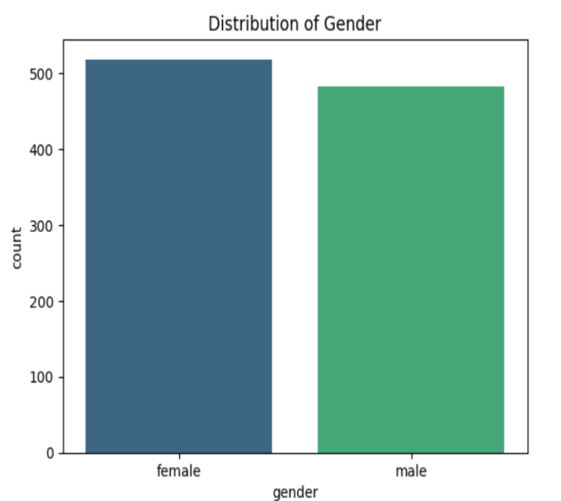

Male population: 482

Women Population: 518

Ratio of approximately 1:1

1. **GENERAL PERORMANCE IN MATHEMATICS**

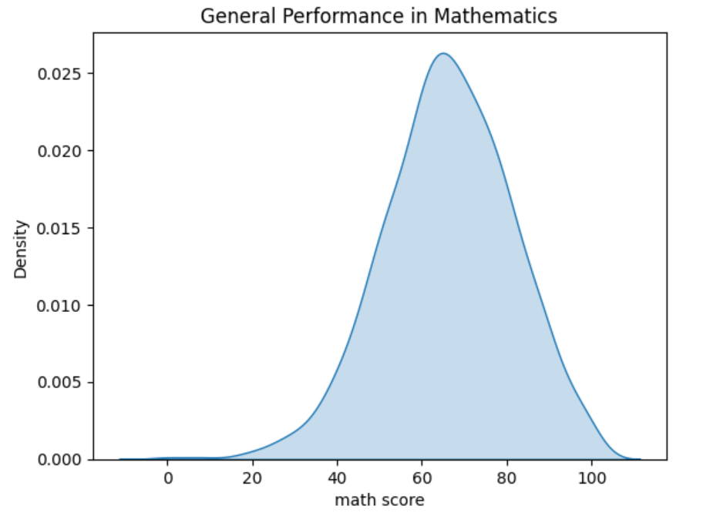

Generally, the average, median and 75th percentile were 66.1, 66 and 77 respectively

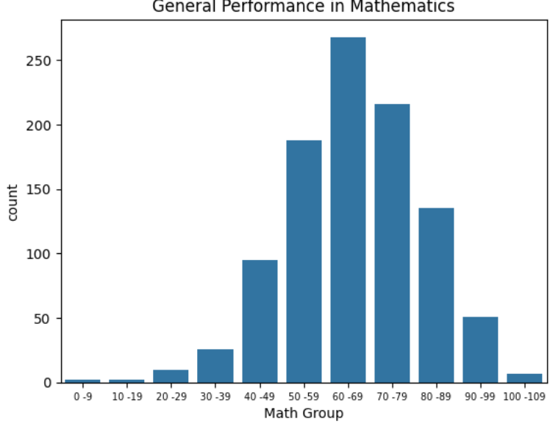

Majority of the scores in maths were between 60-69 and 70-79

1. **EFFECTS OF GENDER ON MATHS**

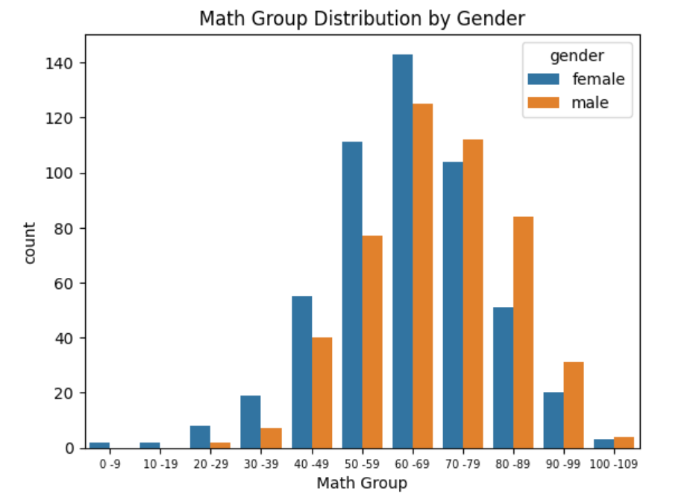

From the count plot the majority of math scores for both male and female were in the range of 60-69

Mean and 75th percentile for female math scores were 63.6 and 74 respectively

Mean and 75th percentile for male math scores were 68.7 and 79 respectively

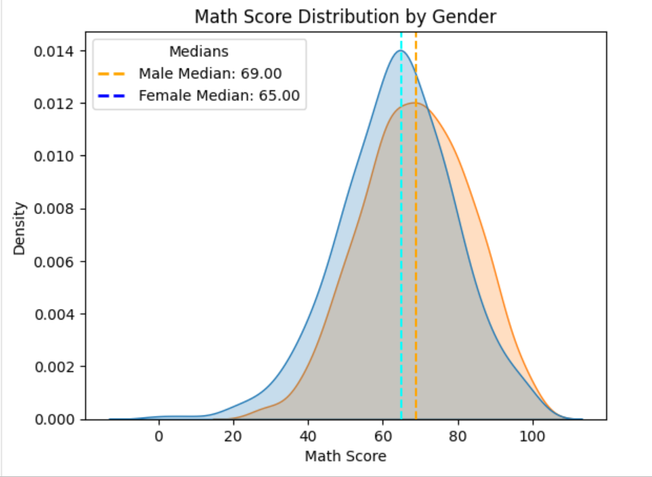

Minimum math score for both genders was 0 and the maximum max score was 100 with a median of 66 however of both genders, Male students tend to score higher than female students in maths.

1. **PERFORMANCE BASED ON ETHNICITY**

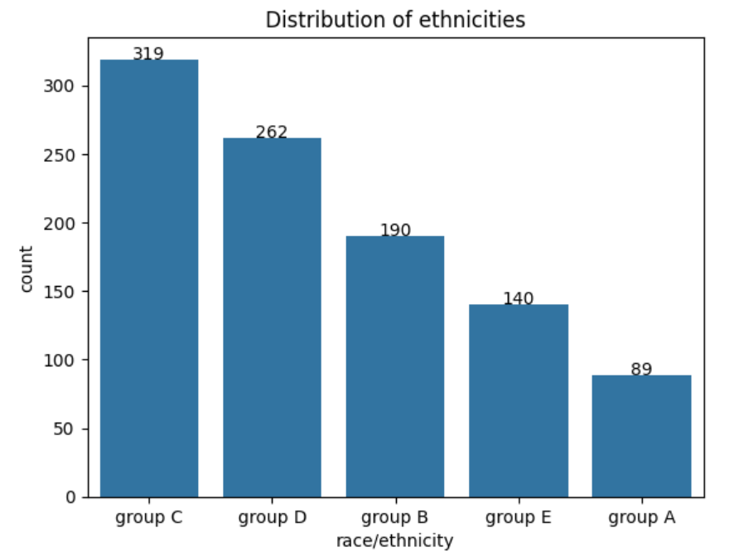

Group C and Group D represents the majority of the data amounting to 31.9 and 26.2 percent respectively

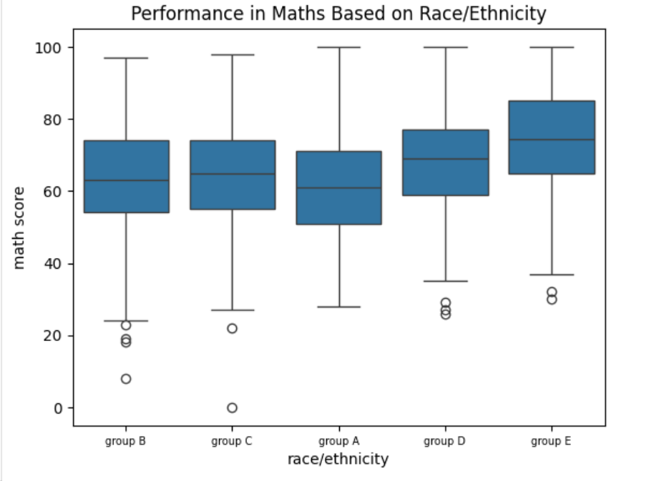

From the analysis on the performance in math based on race/ethnicity Group E performed far better than any other racial group as indicated by their median and 75th Percentile values of 74.5 and 85 respectively being higher than the national average of 66 and 77 respectively the same can also be inferred about Group D as they were the next group with a good performance in mathematics.

The table below shows a summary statistic of the box and whisker plot shown above

|  |  |  |  |  |  |  |
| --- | --- | --- | --- | --- | --- | --- |
| Race/Ethnicity | Mean | Min | 25th Percentile | 50th Percentile | 75th Percentile | Max |
| Group A | 61.62 | 28.00 | 51.00 | 61.00 | 71.00 | 100.00 |
| Group B | 63.45 | 8.00 | 54.00 | 63.00 | 74.00 | 97.00 |
| Group C | 64.46 | 0.00 | 55.00 | 65.00 | 74.00 | 98.00 |
| Group D | 67.36 | 26.00 | 59.00 | 69.00 | 77.00 | 100.00 |
| Group E | 73.82 | 30.00 | 64.75 | 74.50 | 85.00 | 100.00 |

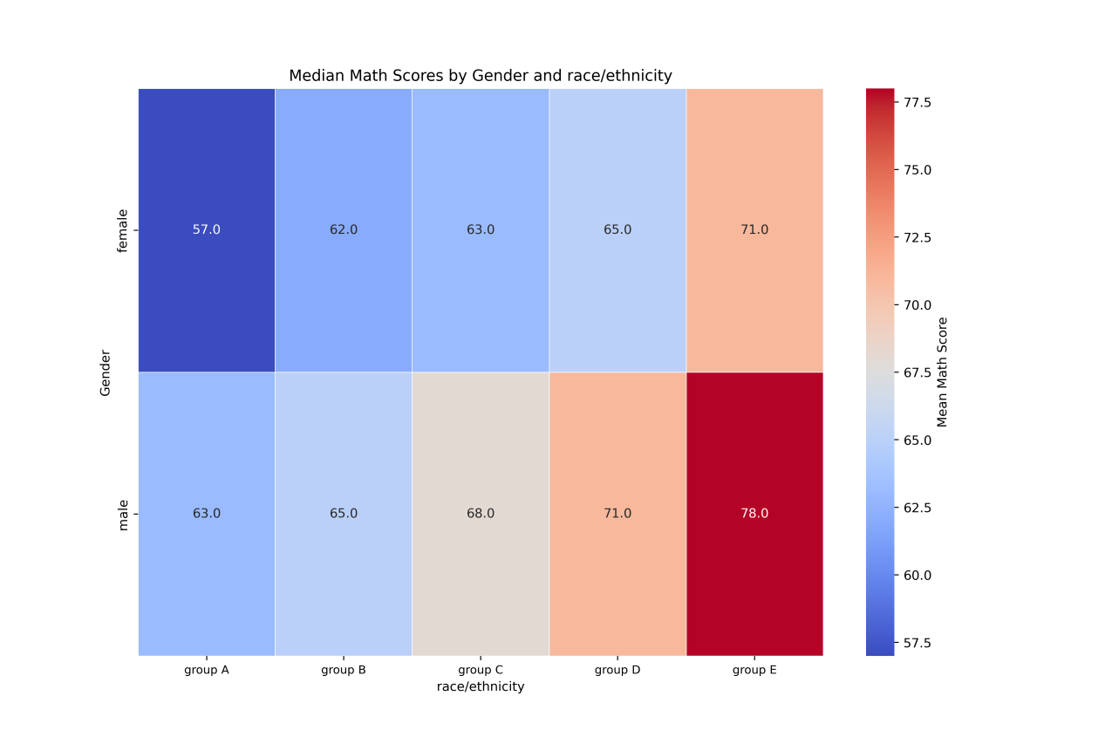

Among all gender and race/ethnicity combinations, **male students in Group E** had the highest performance, with a **median math score of 78.0**. This was followed by **male students in Group D**, who had a **median of 71.0**, closely matched by **female students in Group E**, with a **median of 71.0** as well. These results indicate that students from **Group E and Group D**, particularly males, demonstrated the strongest median performance in math, outperforming all other demographic groups in the dataset.

Male and female students belonging to race/ethnicity Group E irrespective of the level of education attained by the parents outperformed all other races by a large margin.

1. **EFFECT OF TEST PREP**

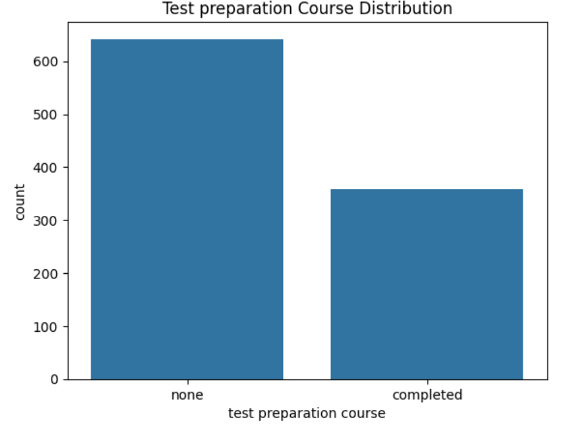

Of the 1000 students that wrote the math exam, 358 completed some form of test preparation course in anticipation for the exam whilst 642 did not.

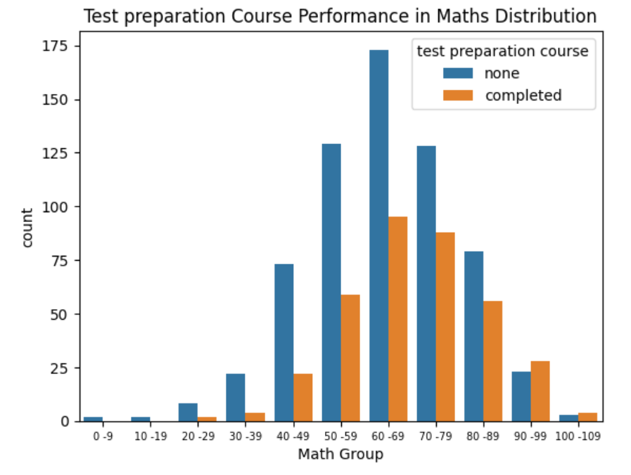

Majority of scores for both those who took some form of preparatory class and those who did not were in the 60-69 range which is consistent with previous case studies

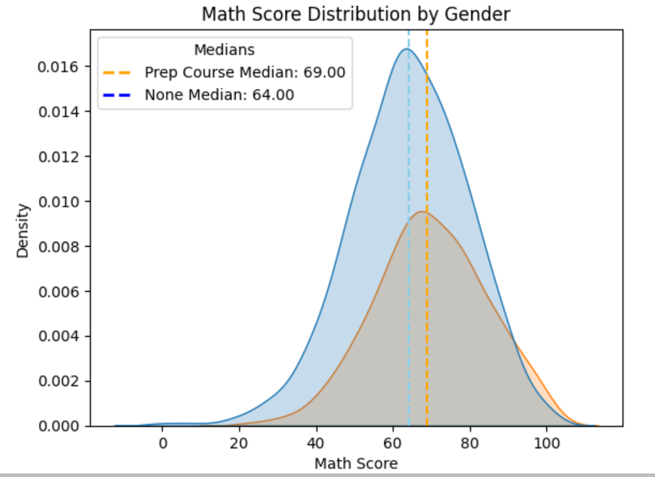

Individuals who took some form of preparatory classes performed better than those who did not as shown above. Also those who completed some form of prep classes had a mean and median of approx. 70 and 69 respectively compared to those who did not (mean: 64.1 , median:64)

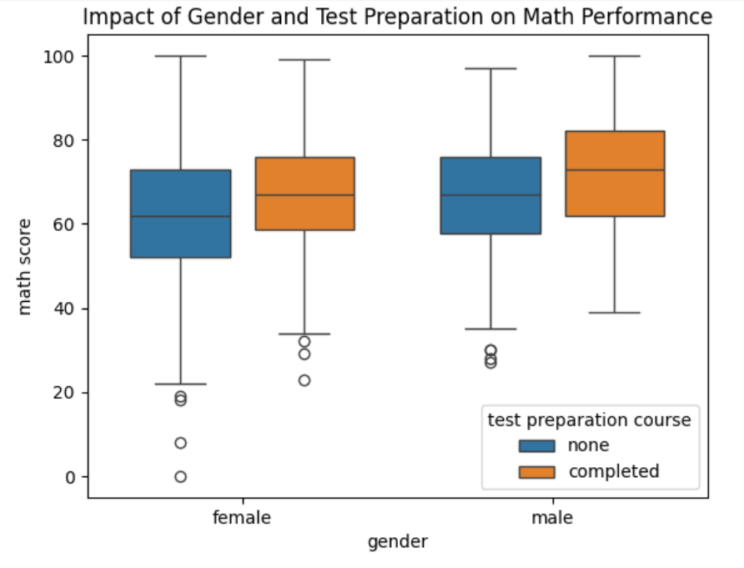

As stated earlier, Students who completed the test preparation course consistently outperformed those who did not, across both genders. Among females, the **mean math score** increased from **61.7** (no prep) to **67.2** (completed), with the **median** rising slightly from **62.0** to **67.0**. For males, the improvement was even more pronounced: the **mean** rose from **66.7** to **72.3**, and the **median** from **67.0** to **73.0**. This suggests that test preparation has a positive effect on math performance, with a slightly greater impact observed among male students. The table below shows a summary of this.

| **Gender** | **Test Preparation Course** | **Mean** | **Median (50%)** | **Min** | **Max** |
| --- | --- | --- | --- | --- | --- |
| **Female** | Completed | 67.2 | 67.0 | 23 | 99 |
|  | None | 61.7 | 62.0 | 0 | 100 |
| **Male** | Completed | 72.3 | 73.0 | 39 | 100 |
|  | None | 66.7 | 67.0 | 27 | 97 |

1. **EFFECT OF LUNCH**

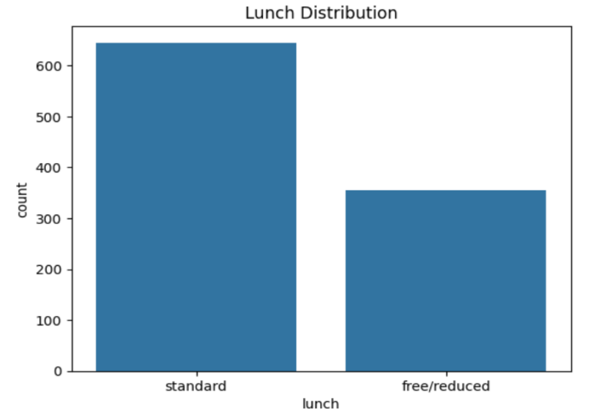

Standard lunch is 645 while free/reduced is 355

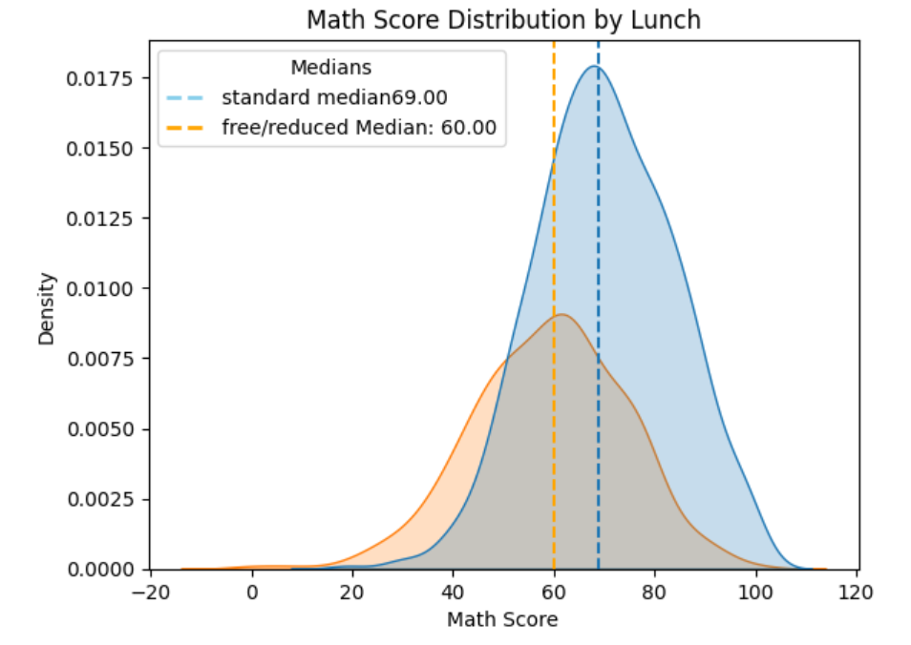

Students who were under a standard meal plan performed way better than those on free/ reduced meals

| **Count** | **mean** | **min** | **25%** | **50%** | **75%** | **max** |
| --- | --- | --- | --- | --- | --- | --- |
| **free/reduced** | 58.9 | 15.2 | 0.0 | 49.0 | 60.0 | 69.0 | 100.0 |
| **standard** | 70.0 | 13.7 | 19.0 | 61.0 | 69.0 | 80.0 | 100.0 |

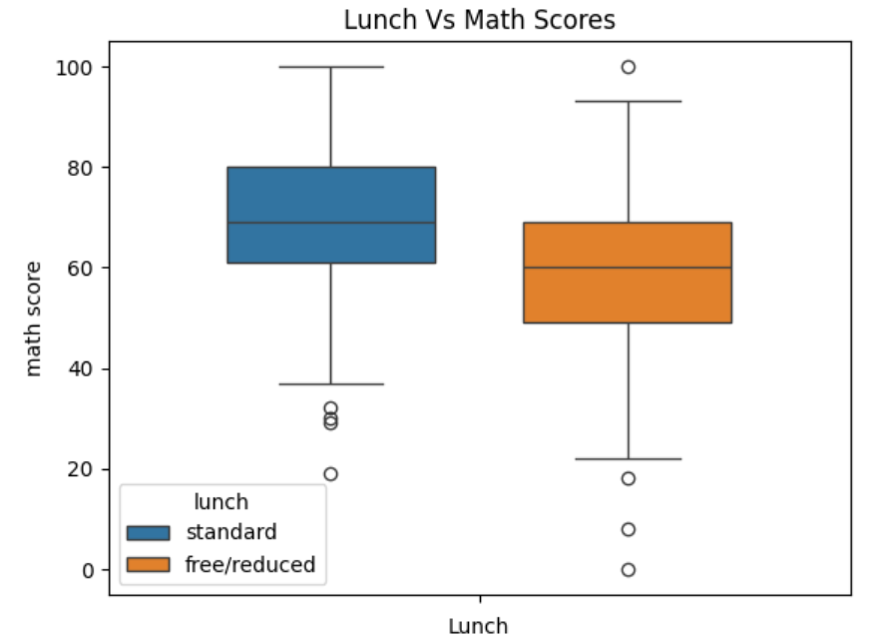

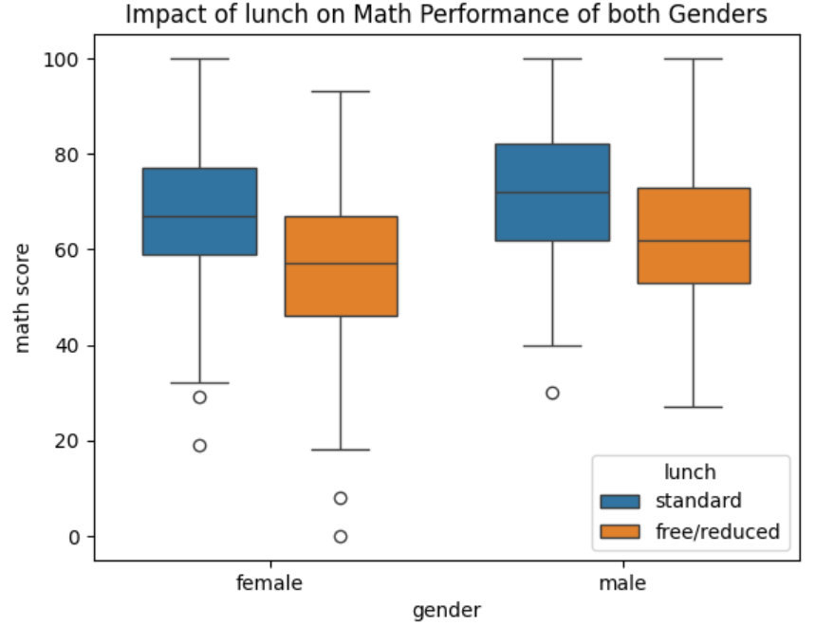

Students receiving **standard lunch** consistently performed better in math compared to those on **free/reduced lunch**, across both genders. However, this effect was more profound in males than in females .Among **females**, the **mean score** rose from **55.8** (free/reduced) to **68.1** (standard), while the **median** increased from **57.0** to **67.0.** Among **males**, the **mean** increased from **62.5** to **72.0**, and the **median** from **62.0** to **72.0**.

| **Gender** | **Lunch Type** | **Mean** | **Median (50%)** | **Min** | **Max** |
| --- | --- | --- | --- | --- | --- |
| **Female** | Free/Reduced | 55.8 | 57.0 | 0 | 93 |
|  | Standard | 68.1 | 67.0 | 19 | 100 |
| **Male** | Free/Reduced | 62.5 | 62.0 | 27 | 100 |
|  | Standard | 72.0 | 72.0 | 30 | 100 |

1. **EFFECT OF PARENT LEVEL OF EDUCATION**

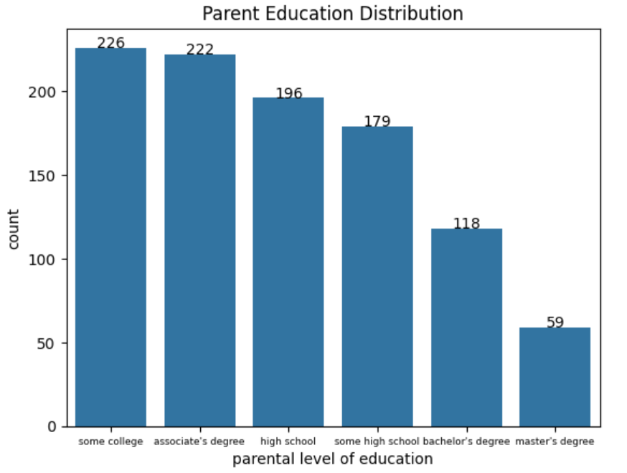

The parents of all students who partook in the maths exam had at least a high school diploma , some had a masters albeit they were in smaller numbers.

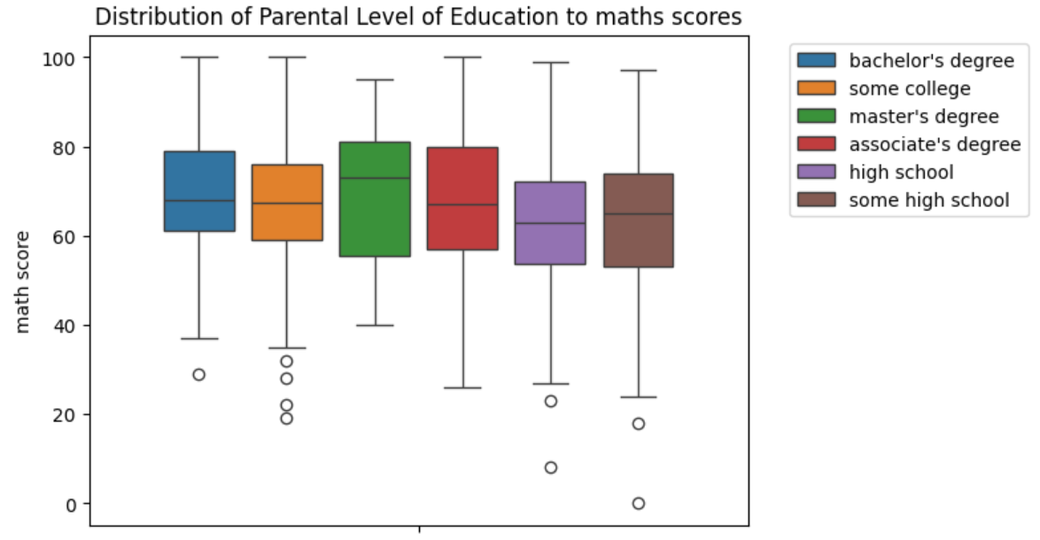

The analysis shows that students whose parents hold higher educational degrees tend to outperform their peers. In particular, students whose parents have a master's degree achieved the highest performance, with a median math score of 73 significantly above the national average.

The table below shows a summarized statistic of the box and whisker plot shown above

| **Parental Level of Education** | **Mean** | **Min** | **25%** | **Median (50%)** | **75%** | **Max** |
| --- | --- | --- | --- | --- | --- | --- |
| Associate's Degree | 67.9 | 26 | 57.0 | 67.0 | 80.0 | 100 |
| Bachelor's Degree | 69.4 | 29 | 61.0 | 68.0 | 79.0 | 100 |
| High School | 62.1 | 8 | 53.8 | 63.0 | 72.0 | 99 |
| Master's Degree | 69.7 | 40 | 55.5 | 73.0 | 81.0 | 95 |
| Some College | 67.1 | 19 | 59.0 | 67.5 | 76.0 | 100 |
| Some High School | 63.5 | 0 | 53.0 | 65.0 | 74.0 | 97 |

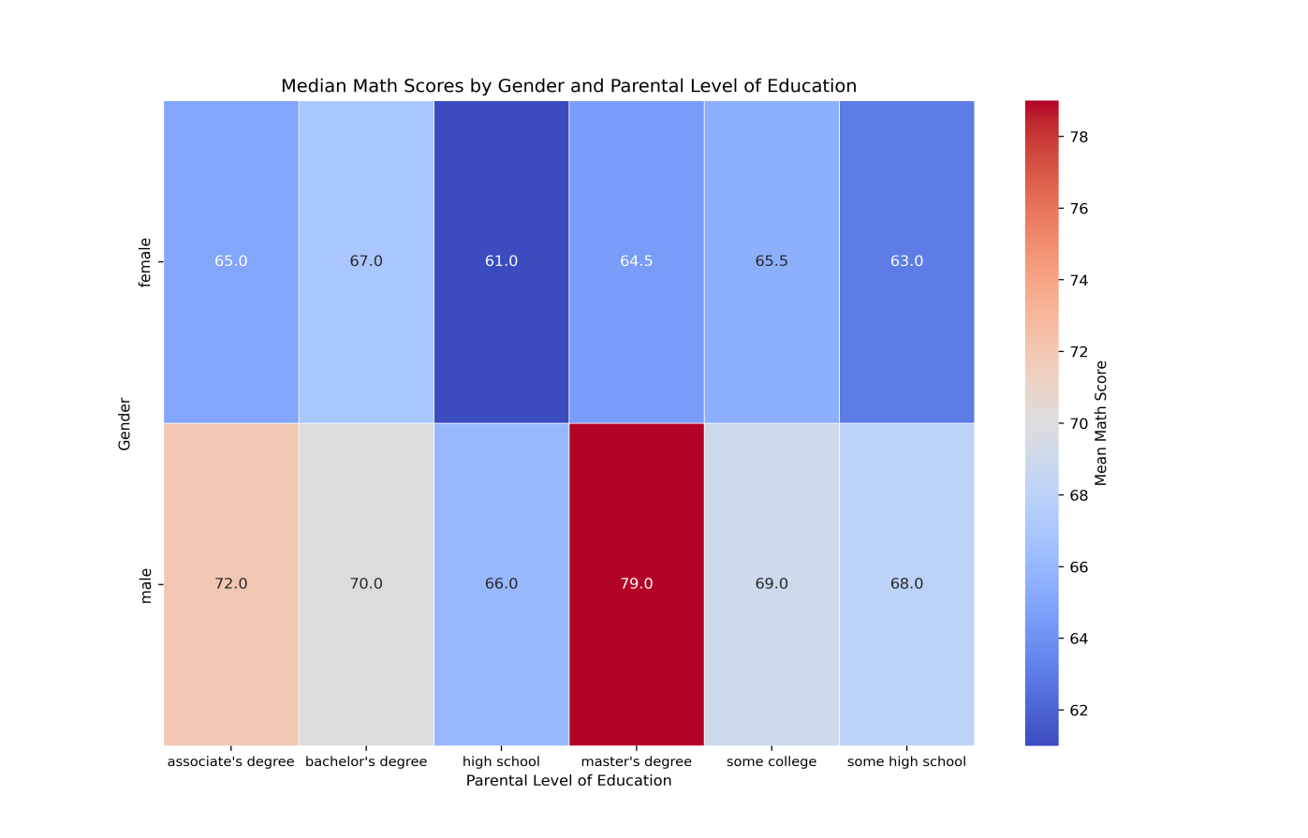

Male students performed way better compared to the national average and female students irrespective of the level of education attained by their parents. However, males students whose parents had a masters degree performed way better than any other male students in the category as indicated by the **median score (79).**

Female students whose parents had a Bachelors degree performed better than other females as indicated by their **median score (67).**

1. **EFFECT OF RACE AND PARENTAL LEVEL OF EDUCATION**

As previously noted, students from race/ethnicity Group E outperformed all other racial groups in the math exam. Notably, within Group E, students whose parents held a master's degree achieved the highest performance, as reflected by a median score of 81, which stands out as the top score among all other parental education levels.

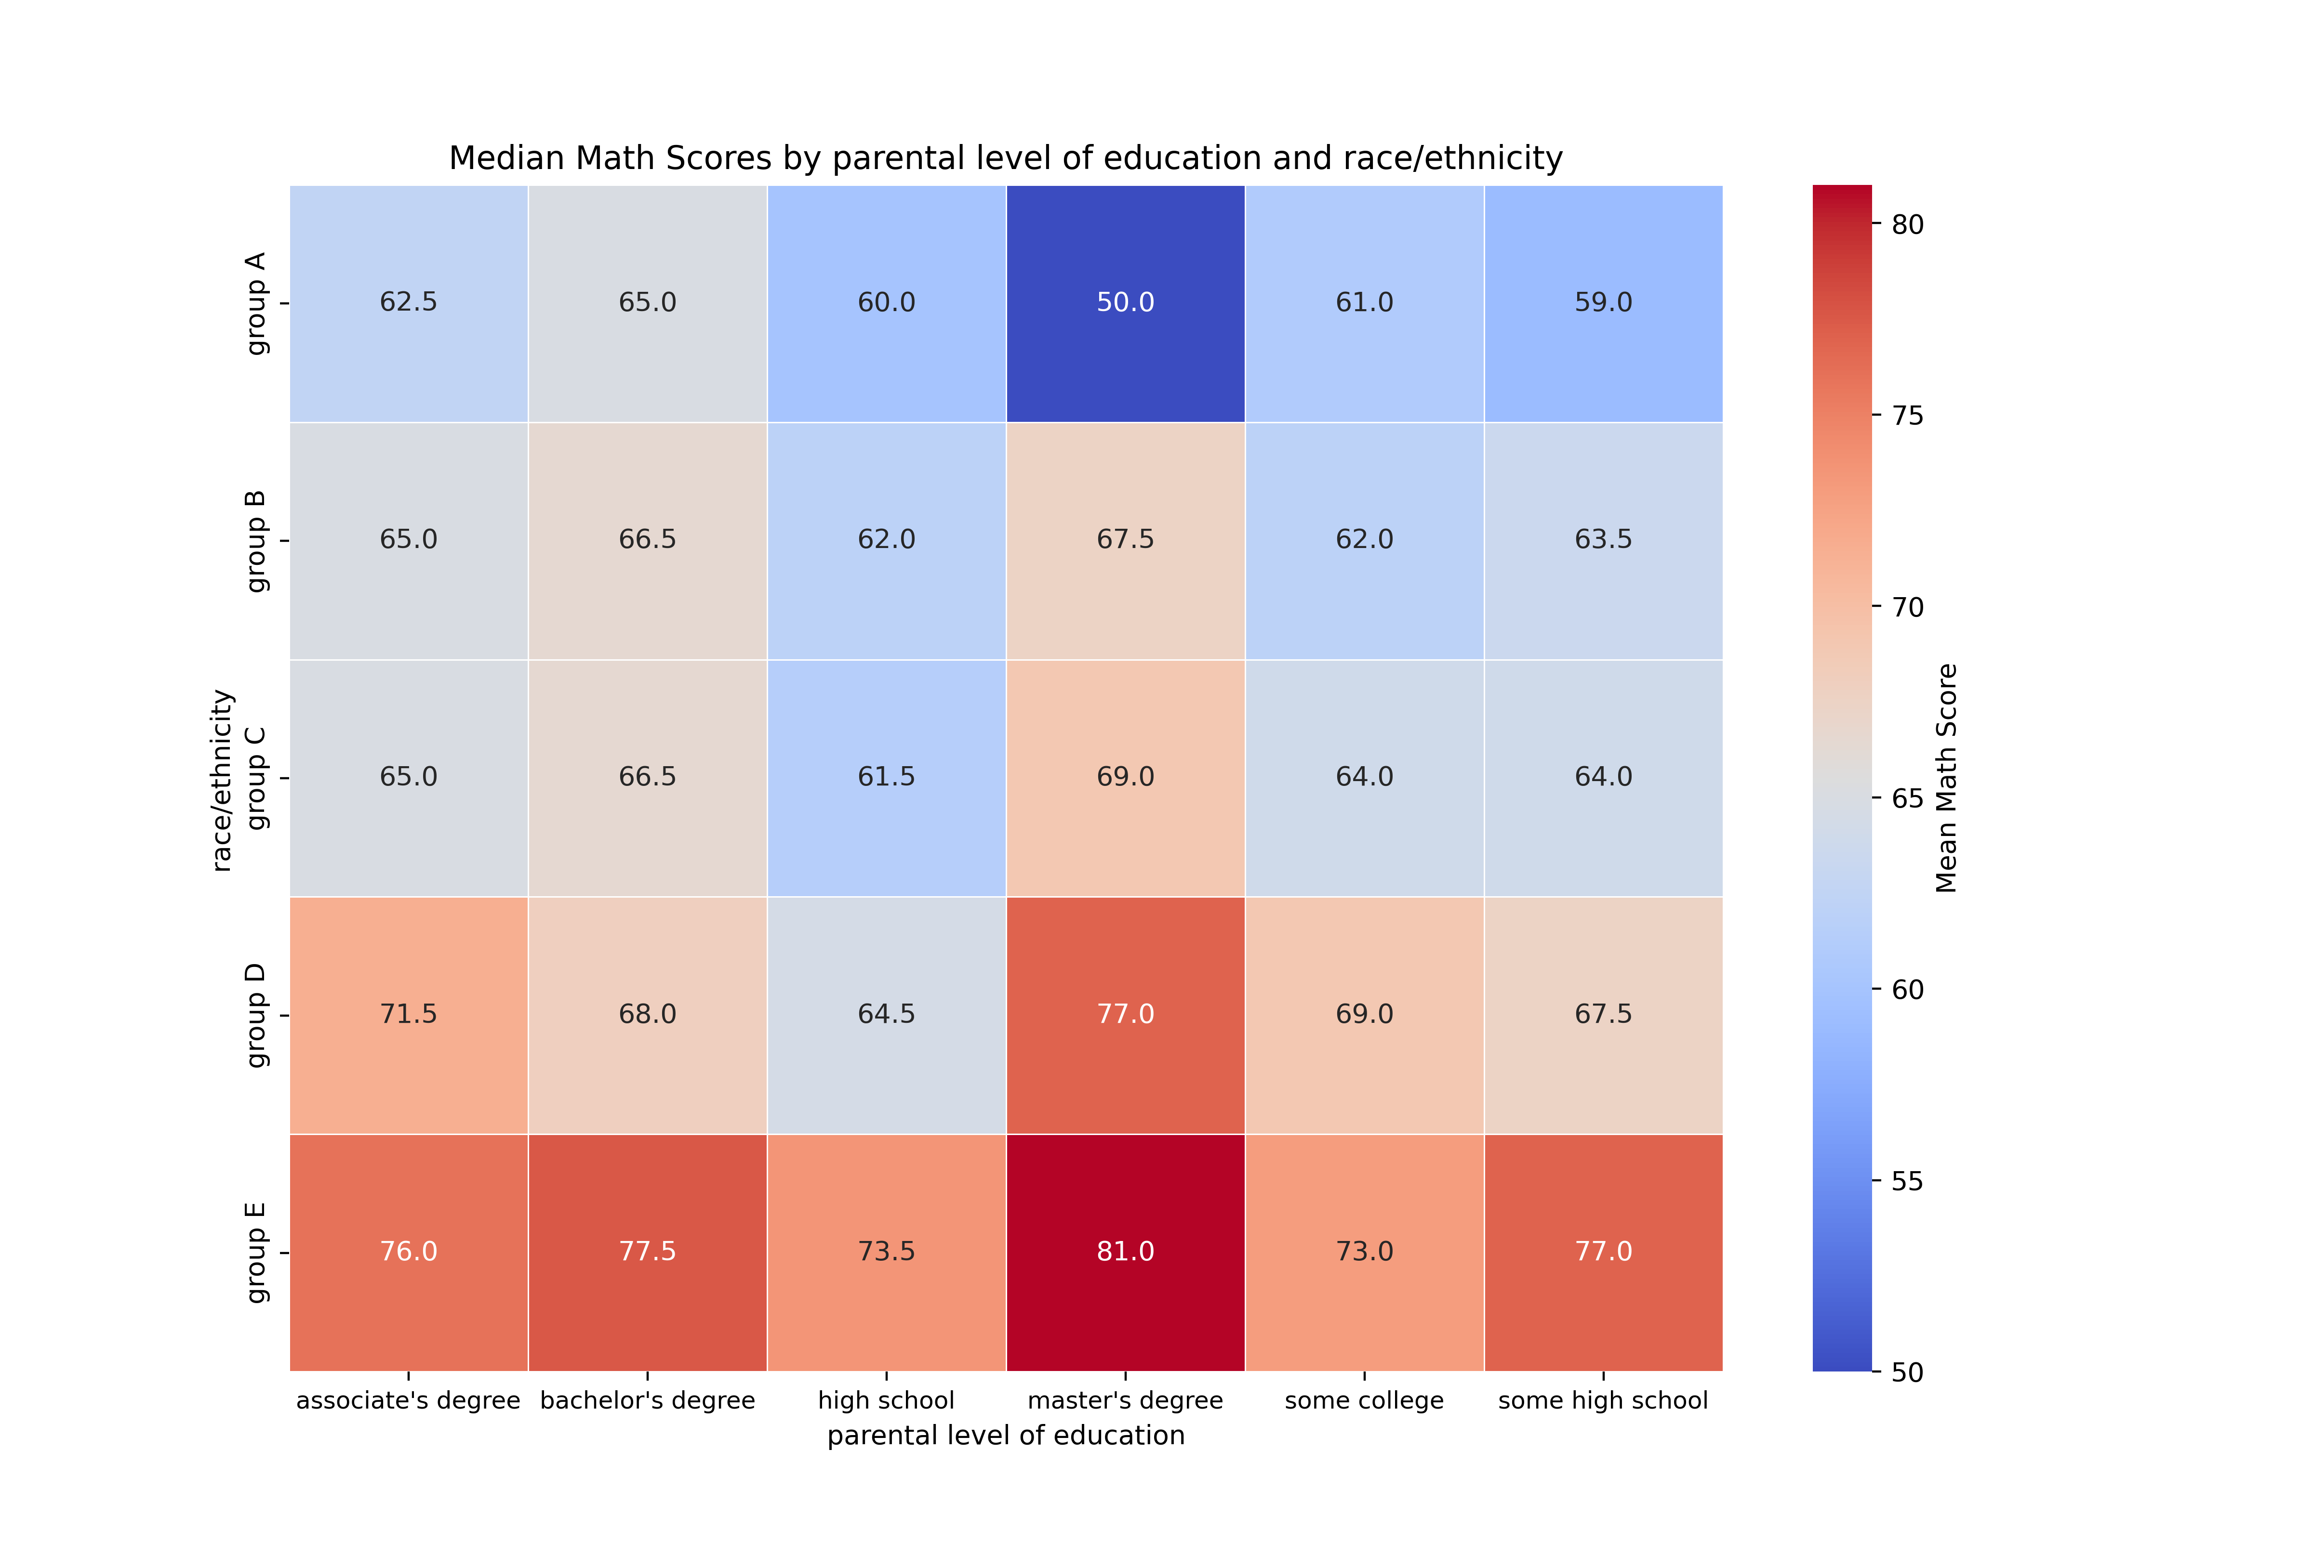

1. **FINAL FINDINGS/SUMMARY**

To lay the groundwork for predictive modeling, I created a new binary variable, **Math Pass**, which flags whether a student scored above the national math average of 66. Scores greater than 66 were labeled as 1 (pass), and those 66 or below as 0 (fail). After applying one-hot (dummy) encoding to the categorical variables, I computed the correlation matrix using the .corr() function.

### Key Findings:

1. **Positive correlations with Math Pass were observed for the following variables:**

* Students who had **standard lunch** (Lunch_standard)
* Belonged to **race/ethnicity Group E**
* **Completed test preparation**
* Were of **male gender**
* Belonged to **race/ethnicity Group D**
* Had parents with a **master’s degree**
* Had parents with a **bachelor’s degree**
* Had parents with **some college education**

These findings align with earlier observations from our exploratory analysis.

**B) Conversely, negative correlations** were found with most other variables, indicating they are associated with a lower likelihood of passing the math exam.

